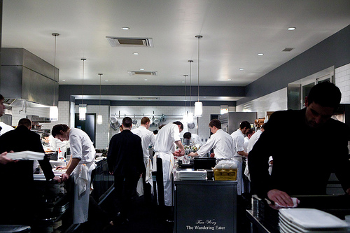
BRIGADE SYSTEM

Executive Chef: The term literally means "the chief" in French. Every kitchen has a chef or executive chef who is responsible for the operations of the entire kitchen. (A commonly misused term in English, not every cook is a chef.) Plan and direct food preparation and cooking duties of several restaurants in an establishment, chains, hospitals or other establishments with food services .Plan menus and ensure food meets quality standards. Estimate food requirements and may estimate food and labor costs. Supervise activities of sous-chefs, specialist chefs, chefs and cooks . Arrange for equipment purchases and repairs .Recruit and hire staff. May prepare and cook food on a regular basis, or for special guests or functions.
Sous-Chef:
This position means "the under chief" in French. This is person is second in command and takes responsibility for the kitchen operations if the chef is absent.
Supervise activities of specialist chefs, chefs, cooks and other kitchen workers
Demonstrate new cooking techniques and new equipment to cooking staff
May plan menus and requisition food and kitchen supplies
May prepare and cook meals or specialty foods.
Chef de Partie:
Also known as a "station chef" or "line cook", is in charge of a particular area of production. In large kitchens, each station chef might have several cooks and/or assistants. In most kitchens however, the station chef is the only worker in that department. Line cooks are often divided into a hierarchy of their own, starting with "First Cook", then "Second Cook", and so on as needed. The Chef de Partie is in charge of any of the following kitchen positions:
Saucier: The person responsible for sautéed items and many different sauces. Traditionally, it is the third person in command. This is usually the highest position of all the stations:
Boulanger: The bread cook
Butcher: Prepares meats, poultry & fish.
Commis: apprentice cook
Communard: chef to the staff.
Confiseur: The candy cook
Entremetier: Prepares vegetables, soups, starches (pasta/rice), and eggs. Large kitchens may divide these duties among the vegetable cook, the fry cook, and the soup cook.
Friturier: The deep fry cook
Grillardin: The grill cook
Legumier: Prepares vegetables.
Poissonier: The fish cook--all fish and shellfish items and their sauces
Pantry chef or Garde Manger: Is responsible for cold foods, including salads and dressings, pâtés, cold hors d'oeuvres, and buffet items.
Patissier: Prepares pastries and desserts.
Potager: The soup and often stock cook
Rotisseur: Prepares roasted and braised meats and their gravies, and broils meats and other items to order. A large kitchen may have a separate broiler cook or grillardin (gree-ar-dan) to handle the broiled items. The broiler cook may also prepare deep-fried meats and fish.
Tournant: The Relief cook. This term describes the cook in the kitchen who provides help to all the different cooks rather than having a specific job.

